Pentagonal Prismoid

Definition
# Source: AI Source: Provided by: [Data Path: Persons Table -> ID Column: 1, Name_En Column: Motasem Essam] -> From: [ChatGPT] on [7/25/2026]
A Pentagonal Prismoid is a three-dimensional polyhedron belonging to the Prismoid family, characterized by two pentagonal bases lying in parallel planes and connected by five quadrilateral lateral faces.
The two bases have five sides each but do not necessarily have the same size, shape, or orientation. The lateral faces are trapezoids or parallelograms.
It has 7 faces, 15 edges, and 10 vertices.

Geometric Structure
# Source: AI Source: Provided by: [Data Path: Persons Table -> ID Column: 1, Name_En Column: Motasem Essam] -> From: [ChatGPT] on [7/25/2026]
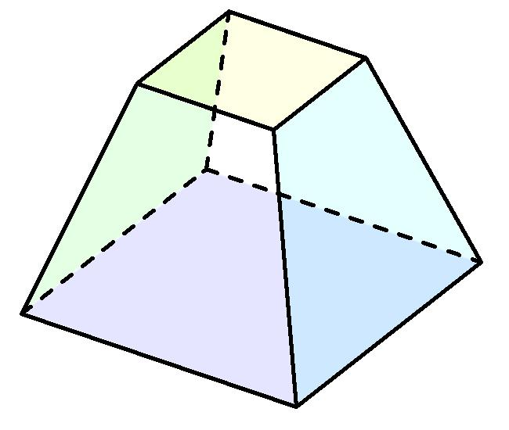
The solid consists of the following elements:
- Lower Pentagonal Base: A five-sided polygon forming the bottom of the solid.
- Upper Pentagonal Base: A pentagon parallel to the lower base.
- Lateral Faces: Five quadrilateral faces connecting corresponding edges of the two bases.
- Lateral Edges: Five edges connecting corresponding vertices of the bases.
- Altitude (Height): The perpendicular distance between the two base planes.
- Midsection: A pentagonal cross-section parallel to both bases, halfway between them.

Face Composition
# Source: AI Source: Provided by: [Data Path: Persons Table -> ID Column: 1, Name_En Column: Motasem Essam] -> From: [ChatGPT] on [7/25/2026]
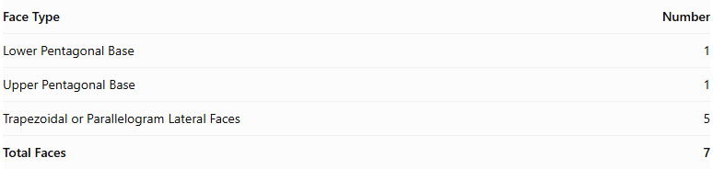
Face Type | Number
Lower Pentagonal Base | 1
Upper Pentagonal Base | 1
Trapezoidal or Parallelogram Lateral Faces | 5
Total Faces | 7
The five lateral faces may be trapezoids or parallelograms, depending on the relative positions and orientations of the bases.

Mathematical Properties
# Source: AI Source: Provided by: [Data Path: Persons Table -> ID Column: 1, Name_En Column: Motasem Essam] -> From: [ChatGPT] on [7/25/2026]
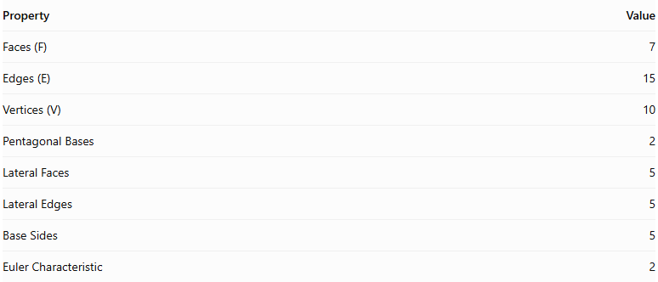
Property | Value
Faces (F) | 7
Edges (E) | 15
Vertices (V) | 10
Pentagonal Bases | 2
Lateral Faces | 5
Lateral Edges | 5
Base Sides | 5
Euler Characteristic | 2
Euler characteristic:
$$V-E+F=10-15+7=2$$
Volume Formula:
$$\boxed{V=\frac{h}{6}(A_{1}+4A_{m}+A_{2})}$$
Where:
- $V$ = Volume.
- $h$ = Perpendicular height.
- $A_{1}$ = Area of the lower pentagonal base.
- $A_{2}$ = Area of the upper pentagonal base.
- $A_{m}$ = Area of the pentagonal midsection.

Geometric Characteristics
# Source: AI Source: Provided by: [Data Path: Persons Table -> ID Column: 1, Name_En Column: Motasem Essam] -> From: [ChatGPT] on [7/25/2026]
- Pentagonal Bases: Both parallel bases have five sides and five vertices.
- Quadrilateral Lateral Faces: The solid has five trapezoidal or parallelogram lateral faces.
- Variable Base Geometry: The upper and lower pentagons may differ in dimensions and shape.
- Inclined Lateral Edges: The connecting edges may be inclined relative to the base planes.
- Convex Structure: In its conventional form, the solid has a convex closed surface.
- Variable Configurations: Its appearance depends on the shapes, dimensions, and relative positions of its two bases.

Types of Pentagonal Prismoids
# Source: AI Source: Provided by: [Data Path: Persons Table -> ID Column: 1, Name_En Column: Motasem Essam] -> From: [ChatGPT] on [7/25/2026]
Pentagonal prismoids can be further classified according to the shapes of their bases:
- Regular Pentagonal Prismoid
- Irregular Pentagonal Prismoid
- Similar-Bases Pentagonal Prismoid
- Non-Similar-Bases Pentagonal Prismoid

Constructing a Pentagonal Prismoid

Geometric Instruments
# Source: AI Source: Provided by: [Data Path: Persons Table -> ID Column: 1, Name_En Column: Motasem Essam] -> From: [ChatGPT] on [7/25/2026]
The following instruments can be used to construct a pentagonal prismoid using traditional geometric drawing methods:
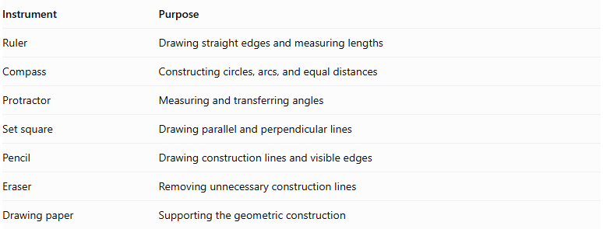
Instrument | Purpose
Ruler | Drawing straight edges and measuring lengths
Compass | Constructing circles, arcs, and equal distances
Protractor | Measuring and transferring angles
Set square | Drawing parallel and perpendicular lines
Pencil | Drawing construction lines and visible edges
Eraser | Removing unnecessary construction lines
Drawing paper | Supporting the geometric construction

Instrument-Based Construction Procedures

Method 1: Constructing from Two Parallel Pentagonal Bases
# Source: AI Source: Provided by: [Data Path: Persons Table -> ID Column: 1, Name_En Column: Motasem Essam] -> From: [ChatGPT] on [7/25/2026]
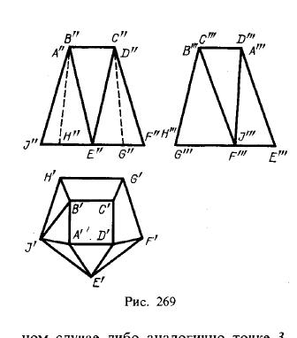
- Draw the lower pentagonal base $ABCDE$ using a ruler, compass, and protractor.
- Draw a second pentagon $A'B'C'D'E'$ above the first, keeping both pentagons in parallel planes.
- Choose the positions and dimensions of the upper pentagon so that the corresponding connecting edges produce planar quadrilateral faces.
- Connect $A$ to $A'$.
- Connect $B$ to $B'$.
- Connect $C$ to $C'$.
- Connect $D$ to $D'$.
- Connect $E$ to $E'$.
- Draw the five lateral quadrilaterals by joining the corresponding base edges.
- Erase unnecessary construction lines and distinguish visible edges from hidden edges.

Method 2: Constructing from a Pentagonal Base and Its Parallel Upper Section
# Source: AI Source: Provided by: [Data Path: Persons Table -> ID Column: 1, Name_En Column: Motasem Essam] -> From: [ChatGPT] on [7/25/2026]
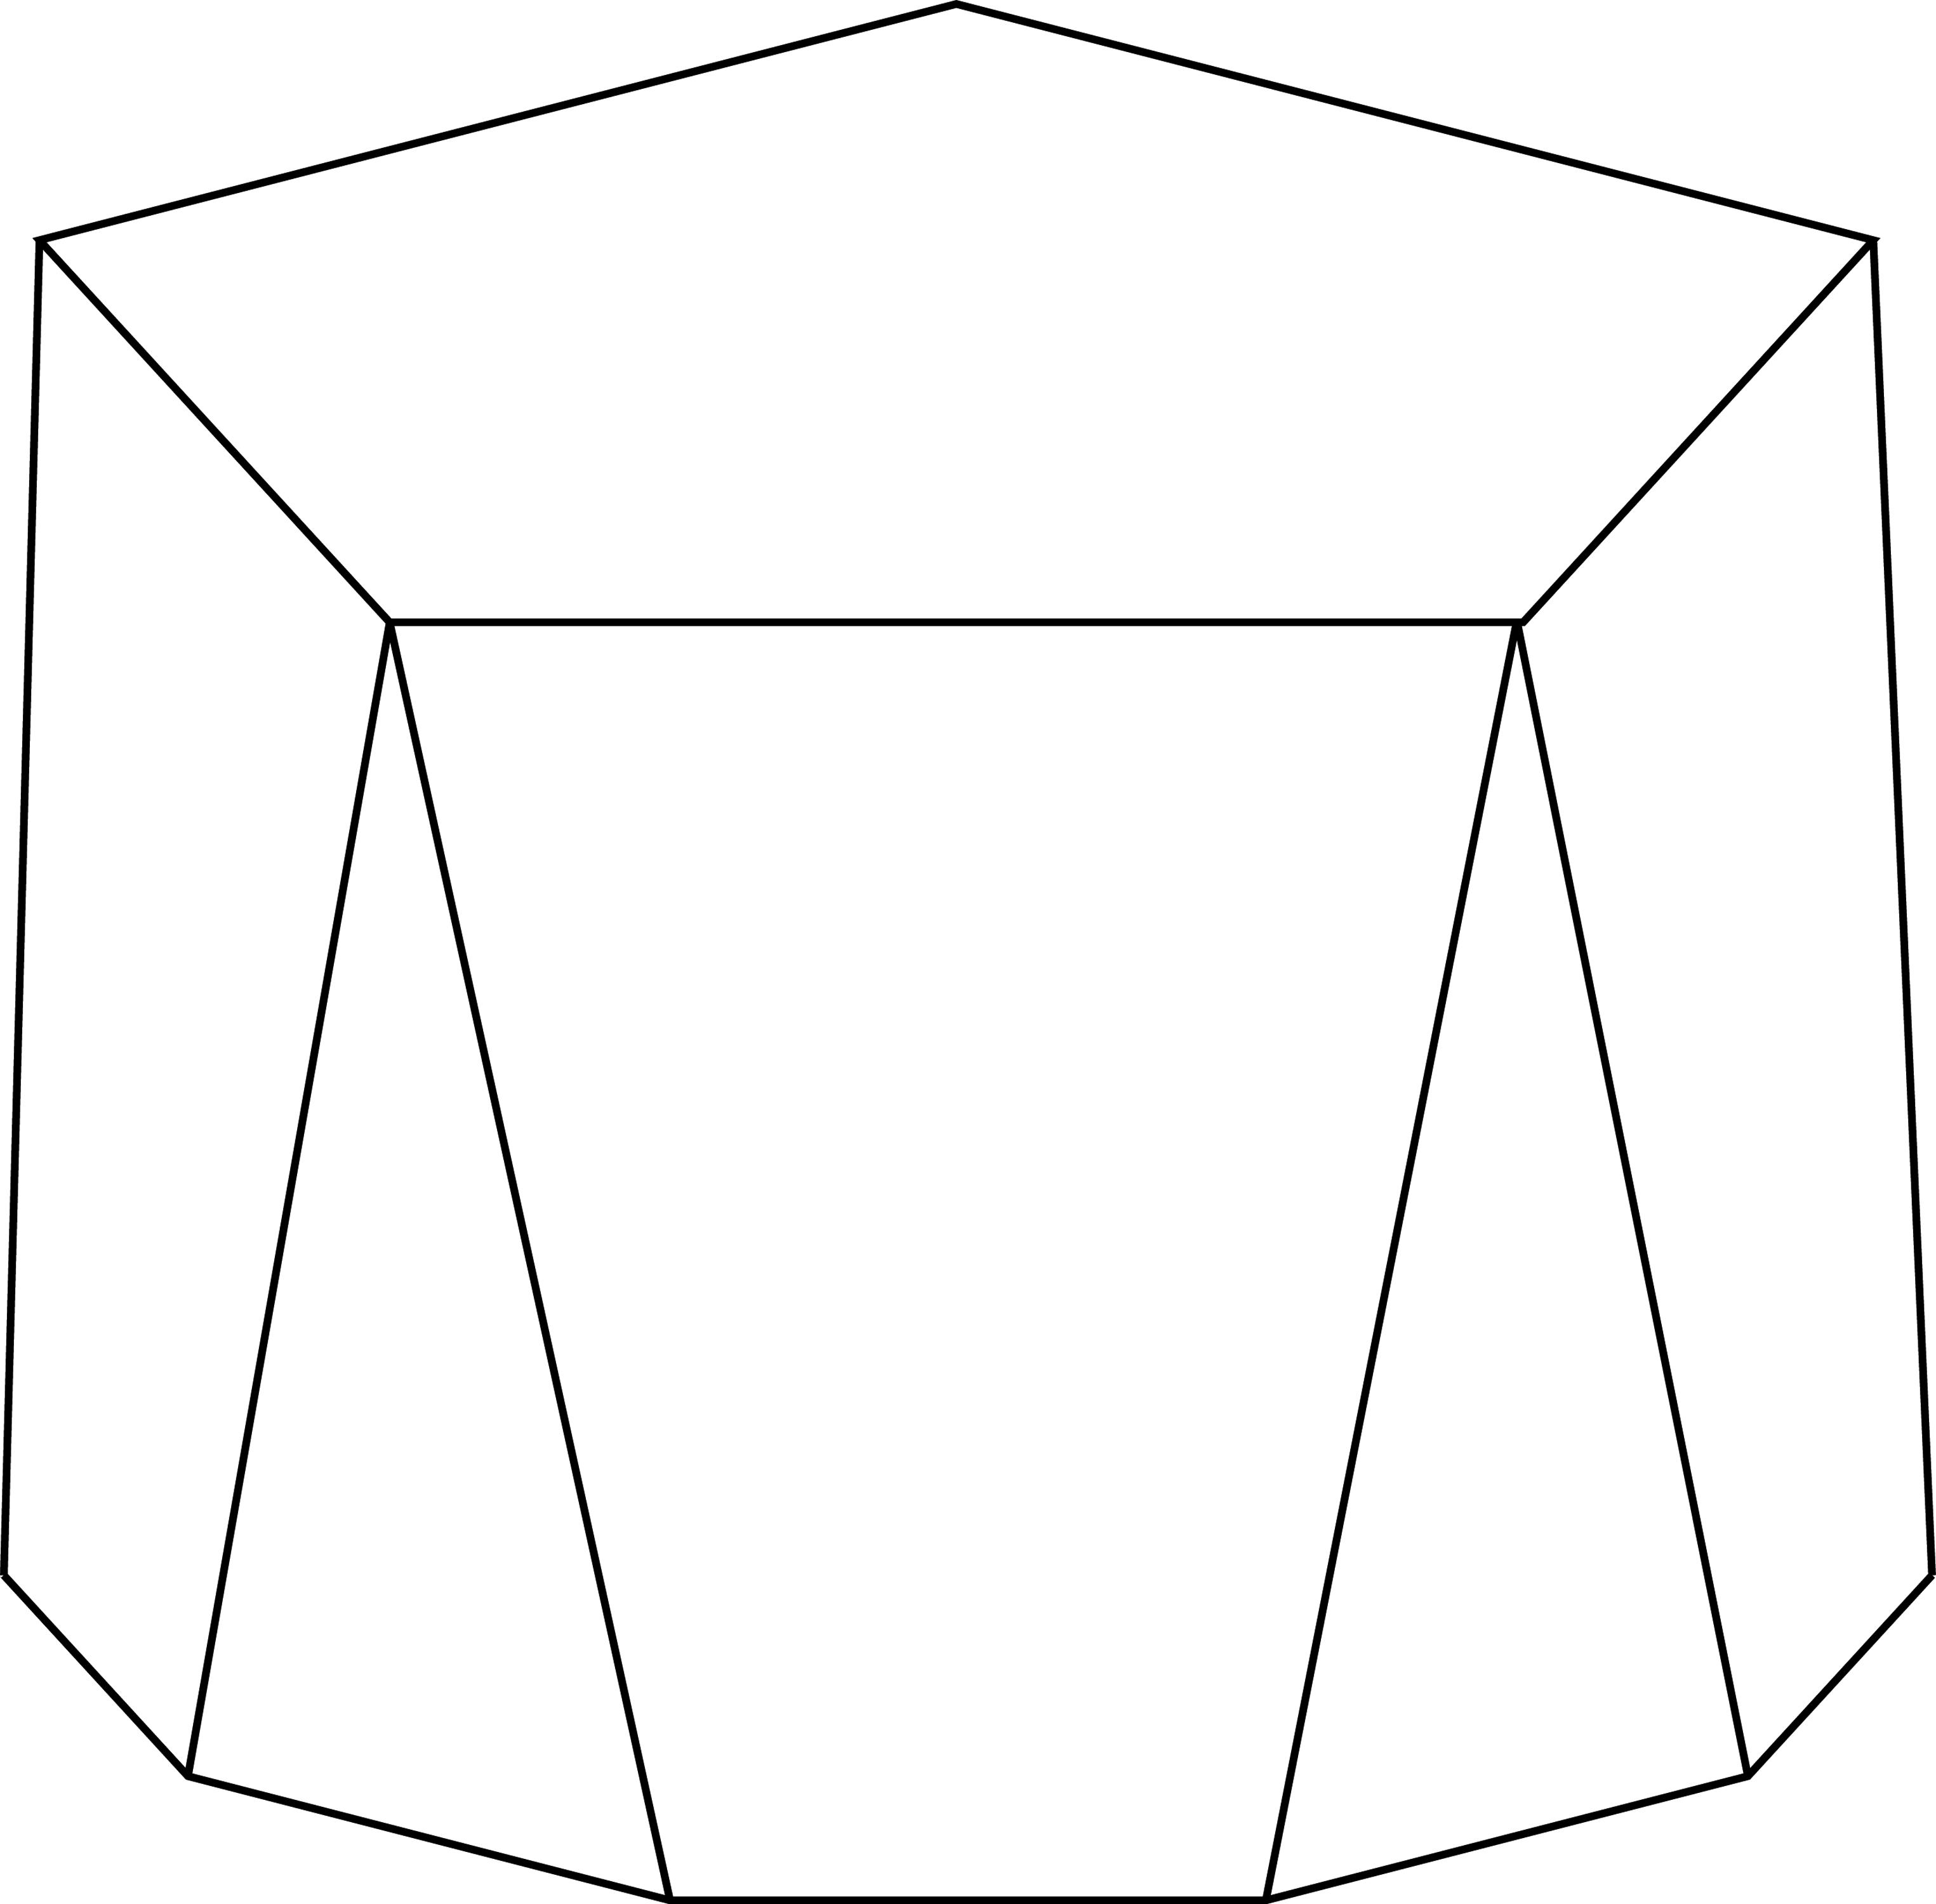
- Construct a pentagon $ABCDE$ as the lower base.
- Draw a parallel upper construction plane at the required perpendicular height.
- Construct a second pentagon $A'B'C'D'E'$ on that plane.
- Position the upper pentagon so that each corresponding pair of vertices can be connected to form a planar lateral quadrilateral.
- Connect the corresponding vertices.
- Complete the five lateral faces.
- Check that the upper and lower bases are parallel.
- Finalize the drawing by removing auxiliary lines and marking the visible edges.

Method 3: Constructing Through Parallel Cross-Sections
# Source: AI Source: Provided by: [Data Path: Persons Table -> ID Column: 1, Name_En Column: Motasem Essam] -> From: [ChatGPT] on [7/25/2026]
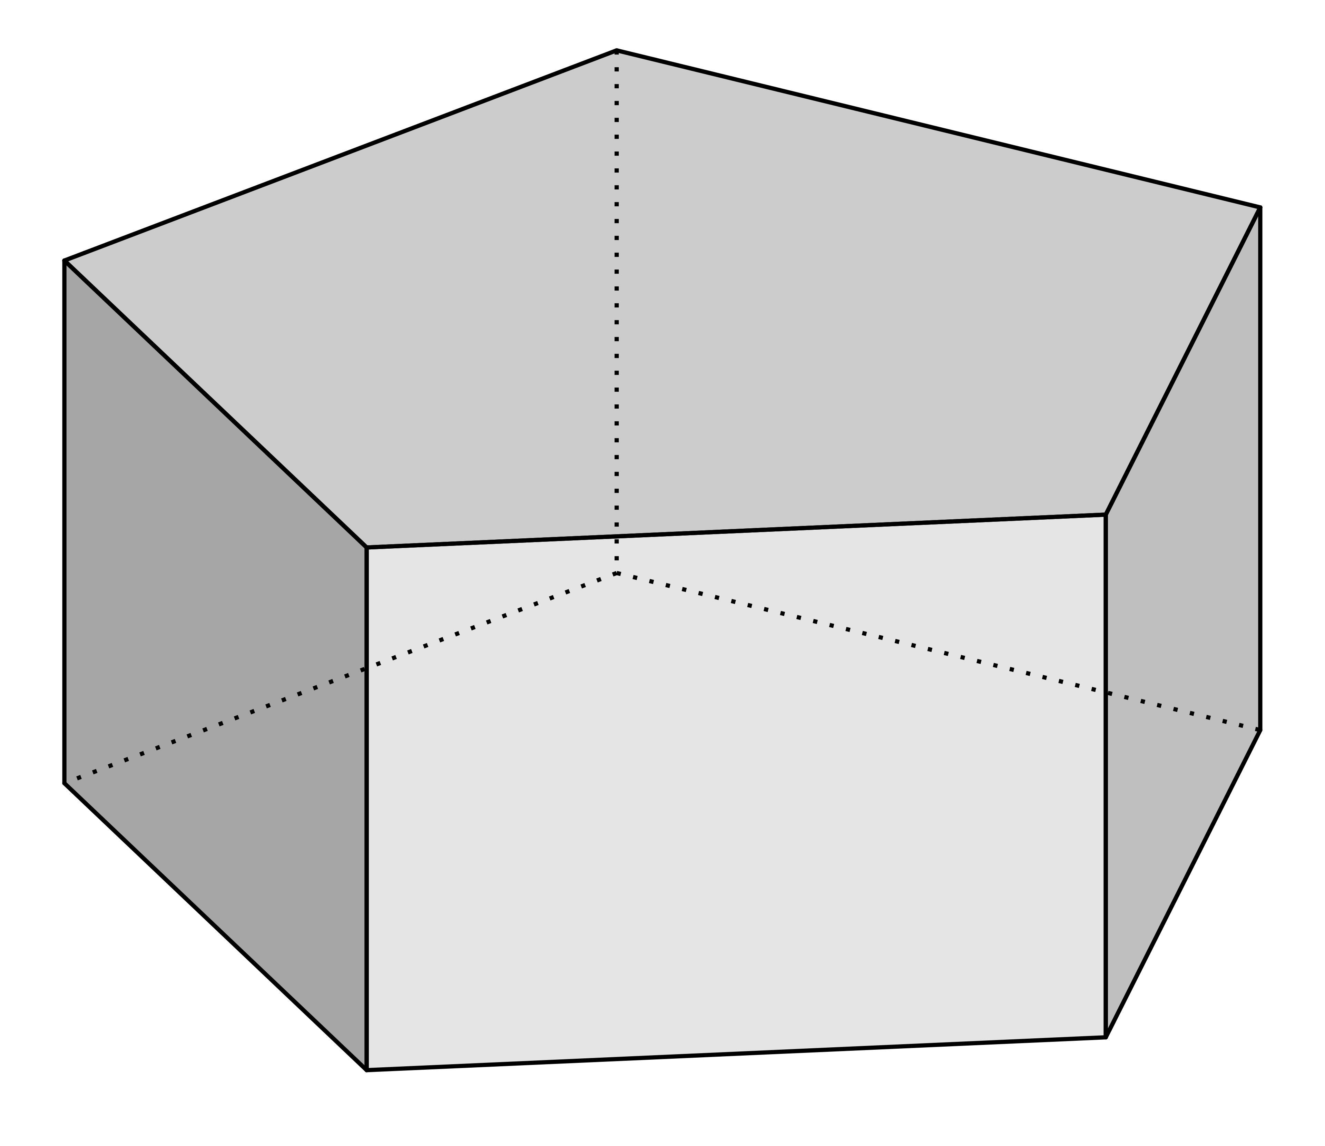
- Draw the lower pentagonal base $ABCDE$.
- Establish the perpendicular height of the solid.
- Mark the halfway level between the two bases.
- Construct a pentagonal middle cross-section $A_{m}B_{m}C_{m}D_{m}E_{m}$, parallel to the bases.
- Construct the upper pentagonal base $A'B'C'D'E'$.
- Connect the corresponding vertices of the lower, middle, and upper pentagons.
- Ensure that the resulting lateral faces are planar quadrilaterals.
- Complete the visible and hidden edges.
This method also makes the middle section available for applying the prismoidal volume formula.

Related Geometric Solids
# Source: AI Source: Provided by: [Data Path: Persons Table -> ID Column: 1, Name_En Column: Motasem Essam] -> From: [ChatGPT] on [7/25/2026]
- Pentagonal Prism – A special case with congruent parallel pentagonal bases.
- Pentagonal Pyramidal Frustum – A related solid with similar pentagonal bases.
- Pentagonal Prismatoid – The broader related geometric category.
- Pentagonal Cupola – A related pentagonal-faced polyhedron, but not a pentagonal prismoid.

Main Classification
# Source: AI Source: Provided by: [Data Path: Persons Table -> ID Column: 1, Name_En Column: Motasem Essam] -> From: [ChatGPT] on [7/25/2026]
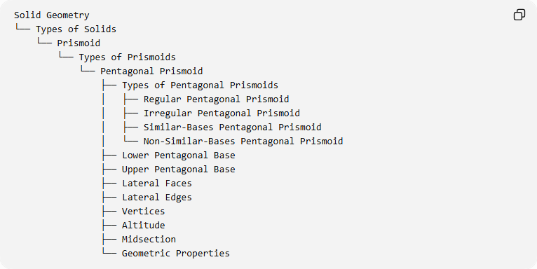
Solid Geometry
└── Types of Solids
└── Prismoid
└── Types of Prismoids
└── Pentagonal Prismoid
├── Types of Pentagonal Prismoids
│ ├── Regular Pentagonal Prismoid
│ ├── Irregular Pentagonal Prismoid
│ ├── Similar-Bases Pentagonal Prismoid
│ └── Non-Similar-Bases Pentagonal Prismoid
├── Lower Pentagonal Base
├── Upper Pentagonal Base
├── Lateral Faces
├── Lateral Edges
├── Vertices
├── Altitude
├── Midsection
└── Geometric Properties

Key Points
# Source: AI Source: Provided by: [Data Path: Persons Table -> ID Column: 1, Name_En Column: Motasem Essam] -> From: [ChatGPT] on [7/25/2026]
- A Pentagonal Prismoid has two parallel pentagonal bases.
- It contains five quadrilateral lateral faces.
- It has 7 faces, 15 edges, and 10 vertices.
- Its bases may differ in size, shape, and orientation.
- Its lateral faces are trapezoids or parallelograms.
- Its volume is calculated using the prismoidal formula.

Conclusion
# Source: AI Source: Provided by: [Data Path: Persons Table -> ID Column: 1, Name_En Column: Motasem Essam] -> From: [ChatGPT] on [7/25/2026]
The Pentagonal Prismoid is the five-sided-base member of the Prismoid family. Its two parallel pentagonal bases and five quadrilateral lateral faces define its structure, allowing different configurations according to the shapes and dimensions of its bases.

